Avinash Kustagi

Rockhurst univrsity | Kansas city

N Stock Portfolio Optimization using GRG Nonlinear Programming for Indian Stocks

1. **INTRODUCTION:**

Selecting the Assets or equites to maximize the profit by minimizing the risk has always been a major problem for an investor. An Investor always wants to get highest return possible from an investment with minimum risk. However, the risk and the return should be balanced based on the amount of risk the investor desires to take. Selecting the correct portfolio of assets or equites cannot be done just perception, it required strong powerful mathematical models to Optimize the portfolio.

**Expected Returns (ER)** on a stock could be calculated by averaging the historical returns of the stock for a particular period of time and its risk measured by the **Variance (σ)** (or the standard deviation, which is the square-root of the variance)

1. **METHODOLOGY**:

Steps to Optimize the N Stock portfolio by leveraging the **Expected Return(ER)** and Risk - **Variance (σ)**

**STEP 1: EXPECTED RETURN ON STOCK**

**Expected Return** for a stock is calculated by averaging the historical returns over the period of time. (NOTE: For any time, frame, whatever maybe the interval [Daily data (or) Weekly data (or) Monthly data]. **Expected return** should be calculated at Yearly level)

Calculation:

1. Historical prices are taken at **Monthly level** for the selected stocks
2. % Change in the stock Vs previous month is calculated
3. Average monthly returns calculated for the selected period of time
4. Monthly returns are multiplied by 12 to get the yearly Expected Return (ER), for the single selected stock

**Note:**

* **Daily data** – Multiply by No. of working days to convert to yearly returns
* **Weekly level**- Multiply by 52 to convert the weekly data to Yearly Returns

***Example:***

*Average Monthly Return is 1 %*

* *Annual returns = Monthly Returns x 12*

*(Note: For Weekly level data Annaly return calculated by Multiplying with 52)*

**STEP 2: STANDARD DEVIATION OF STOCK**

Using the % change Vs Previous month table, calculate the standard deviation of the stock. Then converted the Monthly Standard deviation at yearly level.

***Example:***

*If Monthly Standard deviation is 1 %*

*Annual Standard deviation = Monthly S.D x √12*

*(Note: For Weekly level data Annaly S.D calculated by Multiplying with √52)*

**STEP 3: CALCULATE COVARIANCE MATIX**

Using the % change Vs Previous month table, calculate the covariance matrix.



*(Steps to calculate Covariance Matrix: Data 🡪 Data Analysis 🡪 Covariance 🡪 Select Input Range data (Matrix of % Change Vs. Previous Month table) 🡪 Select output range)*

**STEP 4: CALCULATE PORTFOLIO RETURN:**

Portfolio return is calculated using expected return of each stocks multiplying by its weight (Weight could be a random no).

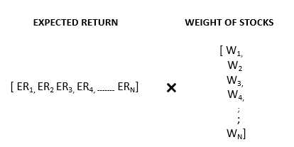

**STEP 5: CALCULATE PORTFOLIO VARIANCE:**

Portfolio Variance is calculated as shown below

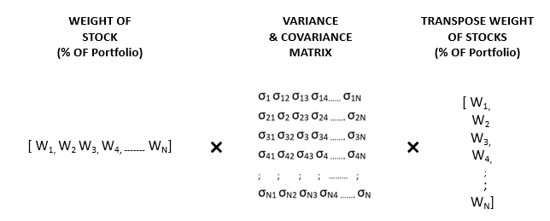

**Illustration of Optimizing the N Stock Portfolio Using GRG Nonlinear Method Using Excel Solver function:**

**2.Input Expected Return from step 1**

**1. Input Random Weights for Each stocks**

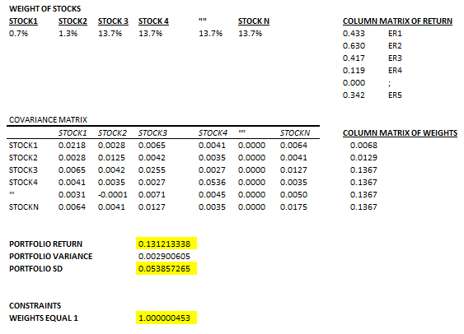

**6. Impose Constrains – Sum of All weights should be 1**

**3. Inputs Covariance Matrix from Step 2**

**4.Transpose Stock Weights**

**5.Calculate Portfolio Returns, Variance and SD Using formulas from above STEP 4 and STEP 5**

Steps to get the Optimized Maximum Portfolio Returns Using Excel Solver:

* Data 🡪 Solver 🡪 Set Objective 🡪 Maximize the Portfolio Returns 🡪 By Changing weights of Stocks 🡪 Constrains Weight of Stocks Should be equal to 1 🡪 Solve for the solution

In the same way we can impose different conditions to optimize the portfolio for Minimize the Risk, Maximize the Returns, Minimize the expected return, Maximizing the Return at Selected Risk (S.D) etc.

1. **DATA DESCRIPTION**

* **Number of Observations:** Listed below are the 17 Stocks from BSE India has been considered for portfolio optimization



(* Note 🡪 Data Not Available)

* **Time Period:** Jan 2010 to July 2016
* **Predictor Variable:** Optimizing the Weight of Stock for Maximizing the Profit with minimal Risk

1. **EXPLORATORY DATA ANALYSIS**





From the above table **Castex Technologies** being the worst performer among all the stock with least Expected Returns over the time with Highest return adjusted risk.

**BSE Mid Cap** turned out as the best performer among all the indexes. However, it also leads the race with the most volatility, the index being the most riskier among all the stocks.

**M&M Finance** turned out as the best stock among the portfolio with respect to the risk involved.

**Page Industry** turned as the best among all the stock with least Return adjusted risk ratio.

**Mean, S.D, Median, Min, Max and Range for All 17 Stocks**

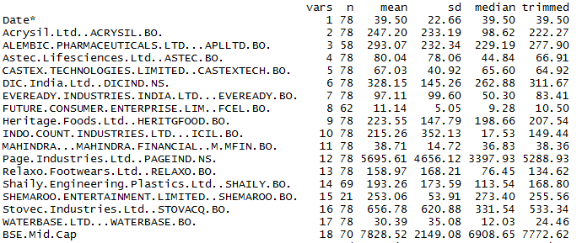

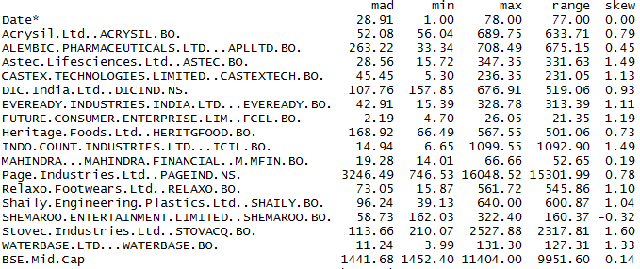

1. **ANALYSIS**

Portfolio is allocated for different scenario

* **Minimum Return:** 100% of the asset getting invested in Castex

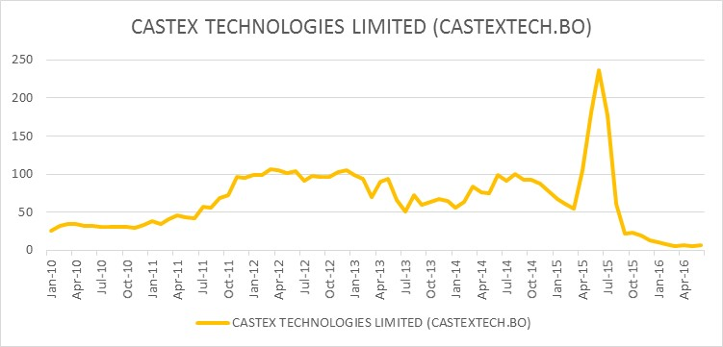

* **Maximum Risk:** Investing 100% in BSE Mid cap sensex turned out as the most risker portfolio
* **Maximum Return:** **BSE Mid Cap** treated as highest risk and highest returns for the selected time period from Jan’2010 to July’2016

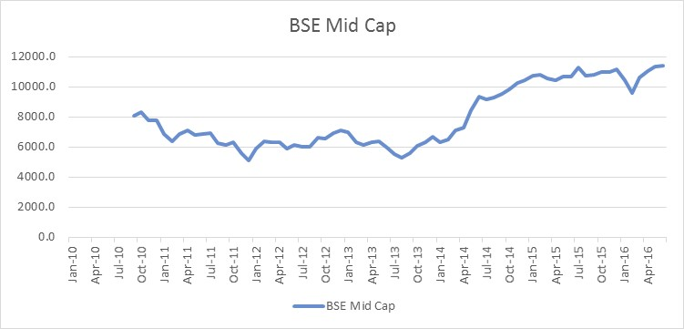

* **Minimum Risk:** NLP algorithm finds investing in Future Consumer, M&M Finance, Page Industry, Stovec Industry could be the safest portfolio with Risk of Just 4% and Average return of 34.4% for the selected time period. If we could observer the correlation between these 4 selected portfolios, they are least correlated or Negative correlated to each other, this help to reduce the overall risk of portfolio significantly with minimum possible returns. In this allocation the main focus of the algorithm to reduce the risk of the portfolio.

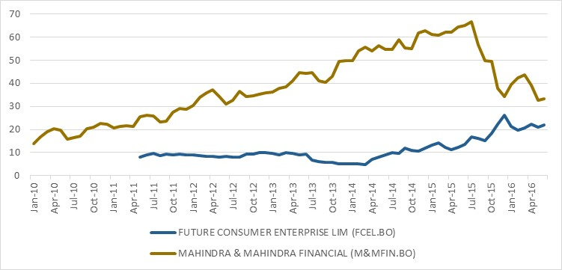

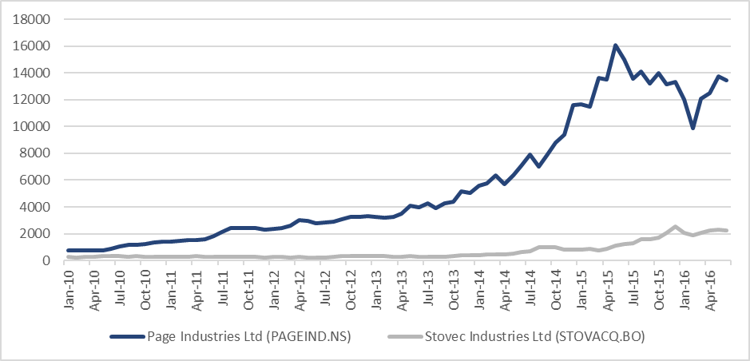

* **Maximizing the Returns at 20% Risk:** Algorithm finds investing in Indo Count industries, Shaily Engineering and BSE Mid cap will give you the maximum returns of approx. 94% with risk of 20%

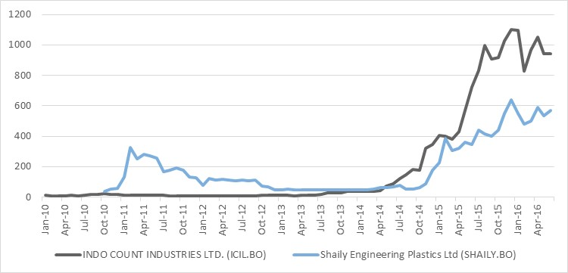

* **Maximizing the Returns at 10% Risk:** By investing in Alembic Pharma, Indo Count industries, Shaily Engineering and Relaxo Footwear will give you the maximum returns of approx. 79% with reduced risk of 10%

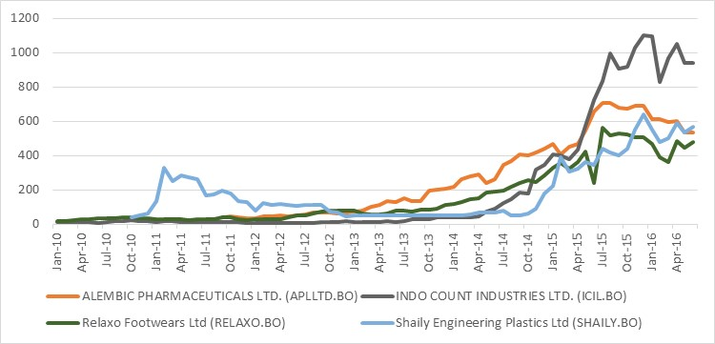

**Summary of Asset allocation for different scenarios:**



1. **References:**

* https://www.encyclopediaofmath.org/index.php/Covariance_matrix
* https://www.encyclopediaofmath.org/index.php/Correlation_matrix
* http://www.solver.com/standard-excel-solver-limitations-nonlinear-optimization
* http://www.solver.com/standard-excel-solver-grg-nonlinear-solver-stopping-conditions
* Yahoo Finance